**Java Web开发**

**实验二**

**作业报告**

|  |  |
| --- | --- |
| 学 院 | 计算机学院 |
| 所在系 班 级 | 2017软件工程 8班 |
| 学 号 姓 名 | 04171602 曹博宇 |
| 指 导 教 师 | 郭晓燕 |
| 完 成 时 间 | 2019年3月17日 |

1.

package cc.Openhome;

import java.io.IOException;

import java.io.PrintWriter;

import javax.servlet.ServletException;

import javax.servlet.annotation.WebServlet;

import javax.servlet.http.HttpServlet;

import javax.servlet.http.HttpServletRequest;

import javax.servlet.http.HttpServletResponse;

@WebServlet("/hello.view")

public class hello extends HttpServlet {

protected void doGet(HttpServletRequest request, HttpServletResponse response) throws ServletException, IOException {

response.setContentType("text/html;charset=UTF-8");

PrintWriter out = response.getWriter();

out.println("<html>");

out.println("<head>");

out.println("<h2>您好，欢迎各位软件工程专业的同学。<br><br>Hello,you</h2>");

out.println("</body>");

out.println("</html>");

out.close();

}

}

package cc.Openhome;

import java.io.IOException;

import java.io.PrintWriter;

import javax.servlet.ServletException;

import javax.servlet.annotation.WebServlet;

import javax.servlet.http.HttpServlet;

import javax.servlet.http.HttpServletRequest;

import javax.servlet.http.HttpServletResponse;

@WebServlet("/test1/hello.view")

public class HelloServlet extends HttpServlet {

protected void doGet(HttpServletRequest request, HttpServletResponse response) throws ServletException, IOException {

response.setContentType("text/html;charset=UTF-8");

PrintWriter out = response.getWriter();

out.println("<html>");

out.println("<head>");

out.println("<h2>您好，欢迎各位软件工程专业的同学。<br><br>Hello,you</h2>");

out.println("</body>");

out.println("</html>");

out.close();

}

}

2.

package test2;

import java.io.IOException;

import java.io.PrintWriter;

import javax.servlet.ServletException;

import javax.servlet.http.HttpServlet;

import javax.servlet.http.HttpServletRequest;

import javax.servlet.http.HttpServletResponse;

public class WelcomeYou extends HttpServlet {

public void doGet(HttpServletRequest request, HttpServletResponse response) throws ServletException, IOException {

String user=request.getParameter("user");

String welcomeInfo="Welcome You "+user+"同学！";

response.setContentType("text/html;charset=UTF-8");

PrintWriter out = response.getWriter();

out.println("<html>");

out.println("<head><title>欢迎页面</title></head>");

out.println("<body>");

out.println(welcomeInfo);

out.println("</body>");

out.println("</html>");

out.close();

}

}

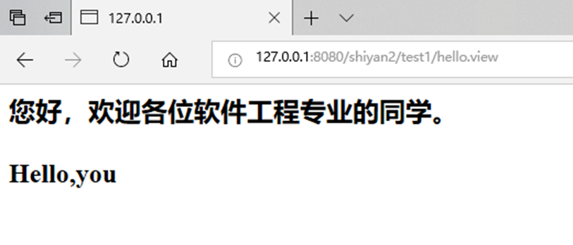

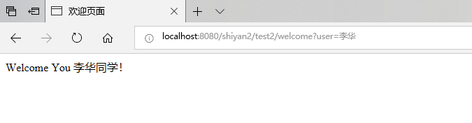

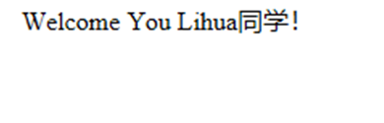

3.

Register.jsp

<%@ page language=*"java"* import=*"java.util.*"* pageEncoding=*"UTF-8"*%>

<!DOCTYPE HTML PUBLIC "-//W3C//DTD HTML 4.01 Transitional//EN">

<html>

<head>

<h1>邮件注册页面</h1>

</head>

<body bgcolor=*"#00FFFF"*>

<form action=*"success.jsp"* method=*"post"* action=*"URL"*>

邮箱账号:

<input type=*"text"* name=*"email"*><br><br>

&nbsp;&nbsp;&nbsp;&nbsp;&nbsp;&nbsp;&nbsp;&nbsp;昵称:

<input type=*"text"* name=*"name"*><br><br>

&nbsp;&nbsp;&nbsp;&nbsp;&nbsp;&nbsp;&nbsp;&nbsp;密码:

<input type=*"password"* name=*"pwd"*><br><br>

确认密码:

<input type=*"password"* name=*"pwd1"*><br><br>

性别:&nbsp;&nbsp;

男<input type=*"radio"* name=*"gender"* value=*"M"* checked>

&nbsp;&nbsp;

女<input type=*"radio"* name=*"gender"* value=*"F"*>

<br><br>

生日:

<select>

<option value=*"old"*>公历</option>

<option value=*"new"*>新历</option>

</select>

<select>

<option value=*"years1993"*>1993年</option>

<option value=*"years1994"*>1994年</option>

</select>

<select>

<option value=*"jan"*>1月</option>

<option value=*"feb"*>2月</option>

<option value=*"mar"*>3月</option>

<option value=*"apr"*>4月</option>

<option value=*"may"*>5月</option>

<option value=*"jun"*>6月</option>

<option value=*"jul"*>7月</option>

<option value=*"aug"*>8月</option>

<option value=*"sept"*>9月</option>

<option value=*"oct"*>10月</option>

<option value=*"nov"*>11月</option>

<option value=*"dec"*>12月</option>

</select>

<select>

<option value=*"days"*>1日</option>

</select>

<br><br>

所在地:

<select>

<option value=*"china"*>中国</option>

</select>

<select>

<option value=*"shandong"*>山东 </option>

</select>

<select>

<option value=*"zibo"*>淄博</option>

</select>

<br><br>

验证码:<input type=*"text"* name=*"yanzhengma"*><br><br>

&nbsp;&nbsp;&nbsp;&nbsp;&nbsp;&nbsp;&nbsp;&nbsp;&nbsp;&nbsp;&nbsp;&nbsp;&nbsp;&nbsp;

<input type=*"submit"* value=*"立即注册"*><br><br>

<input type=*"checkbox"* name=*"g1"* value=*"1"*>我已阅读并同意相关服务条款和隐私政策

</form>

</body>

</html>

Success.jsp

<%@ page language=*"java"* import=*"java.util.*"* pageEncoding=*"UTF-8"*%>

<!DOCTYPE HTML PUBLIC "-//W3C//DTD HTML 4.01 Transitional//EN">

<html>

<body>

<Font size=*8*> <a href=*"register.jsp"*>回到邮件注册页面</a>

<% request.setCharacterEncoding("utf-8");

String yourName=request.getParameter("name");

String yourEmail=request.getParameter("email");

out.println("<br>");

out.println("恭喜"+yourName+"成功注册邮箱");

out.println("<br>");

out.println("您的邮箱账号为:"+yourEmail);

%>

</body>

</html>

Fail.jsp

<%@ page language=*"java"* import=*"java.util.*"* pageEncoding=*"UTF-8"*%>

<!DOCTYPE HTML PUBLIC "-//W3C//DTD HTML 4.01 Transitional//EN">

<html>

<body>

<% request.setCharacterEncoding("utf-8");

out.println("对不起，注册邮箱失败，请返回重新注册<br>");

%>

<Font size=*8*> <a href=*"register.jsp"*>回到邮件注册页面</a>

</body>

</html>

3.

